ADRIAN TURION |  | Avenue de Sainte-Clotilde 9  1205 Geneva, Switzerland | 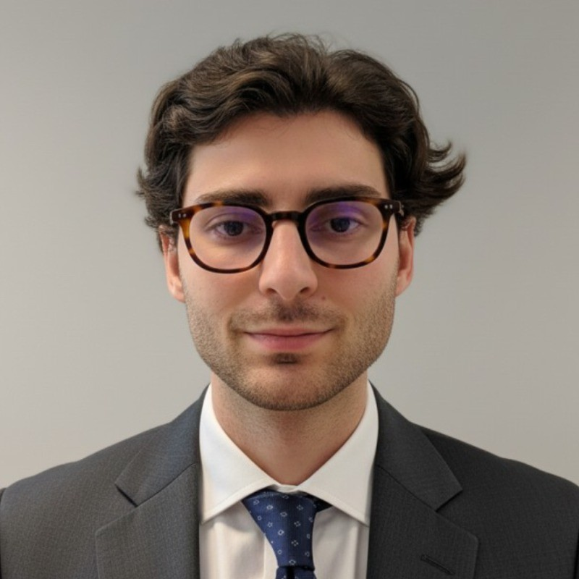
turionadrian@gmail.com | Swiss | 10.11.2000 |  | +41 77 262 37 96
INTRODUCTION
MSc Finance graduate with operational M&A experience in lean environments. At Glencore's Zinc Marketing Department, I will contribute process-oriented execution and analytical rigor to support trade lifecycle operations. Proven ability to thrive in flat structures, delivering results across concurrent mandates while managing multicultural relationships in fast-paced settings.
WORK EXPERIENCE
Auraïa Capital Advisory – Small & Mid Cap Cross-border M&A Boutique  Mergers & Acquisitions Analyst (Converted internship into full-time position) |  | Geneva, Switzerland  Aug 2024 – Current
- Contributed to end-to-end deal execution in lean 3-person team (sourcing, valuation, due diligence, negotiations, closing), thriving in flat organizational structure with high individual responsibility
- Managed relationships with clients, advisors, and counterparties across Europe, US, and Asia throughout transaction lifecycle, developing multicultural communication and stakeholder coordination in fast-paced environments
- Led marketing materials production, maintained buyer universes, and coordinated data room management across 7 concurrent mandates, showcasing process-oriented approach and detail-focused execution under time pressure

RC Group – Currently under LBO with Crédit Mutuel Equity  Mergers & Acquisitions Intern |  | Paris, France  Feb 2024 – Aug 2024
- Prepared investment memos including market analysis, competitive positioning, and financial projections for 3 potential acquisitions (EUR 10M-30M revenues), demonstrating problem-solving skills and ability to synthesize complex information for strategic decision-making

Europ Assistance – Subsidiary of Generali Insurance  Financial Analyst Intern |  | Geneva, Switzerland  Apr 2023 – Aug 2023
- Built automated financial dashboards in Excel and PowerBI to track KPIs and performed variance analysis on monthly P&L results for CHF 50M+ subsidiary, showcasing IT proficiency, process optimization mindset to maximize operational efficiency, and ability to streamline reporting workflows

LEADERSHIP
- Led AIESEC's post-COVID recovery by sourcing leads and negotiating partnerships, closing 3 deals generating CHF 60K revenue (+40% placements), demonstrating resilience
- Founded Screeny.ai, an AI buyer identification tool adopted by 3 M&A firms, reducing search time from 10h+ to 20min, showcasing innovation and diverse task execution
- Manage investment portfolio using options strategies (CSPs, CCs), generating CHF 5K+ premiums through analytical thinking and strategic decisions in fast-paced markets
EDUCATION
HEC Lausanne  Master of Science in Finance |  | Lausanne, Switzerland  2021 – 2024
- Cumulative GPA: 5.2/6.0 (Top 15% of the class cohort)
- Exchange programs at Waseda University (Tokyo, Japan) and Maastricht University (Maastricht, Netherlands)
- Relevant Coursework: Corporate Governance and M&A, Data Science for Finance, Cross-Cultural Management
- Thesis Topic: Synergies Analysis of the Merger between American Airlines & US Airways

Bachelor of Science in Management |  | 2018 – 2021
- Cumulative GPA: 4.7/6.0

Scientific Baccalaureate with Highest Honors (16.6/20) |  | Aix-en-Provence, France
ADDITIONAL INFORMATION
Languages:  Computer:  Interests:  References: | French (Native, C2), Spanish (Native, C2), English (Fluent, C1), German (Business proficient, B2-C1)  Financial Modeling | Data Analysis | Valuation | Process Optimization  Geopolitics, Badminton (Provence regional finalist), Gym, Real use cases of Artificial Intelligence  Guillaume Arnaldez – Ex-Director at Auraïa Capital Advisory, guillaume.arnaldez@auraia.ch  Sacha Caravatti – CFO at Europ Assistance Switzerland, scaravatti@europ-assistance.ch

